7052 Santa Teresa Blvd
San Jose, CA. 95139

For Immediate Release

Remembering 9-11 21 Years Later

2nd Edition of the Poetry Collection, Emergencies of the Heart, by Leslie McGraw, includes special foreword dedicated to the often-forgotten Black lives lost on September 11, 2001

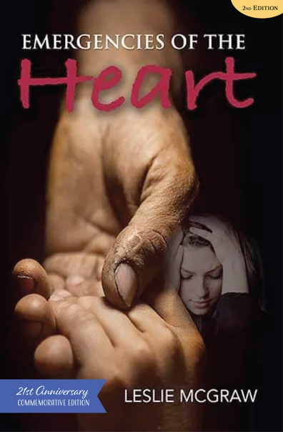
Ann Arbor, Michigan (August 29, 2022) - Poet and Journalist Leslie McGraw will release the second edition of her debut poetry collection, "Emergencies of the Heart" on Thursday, September 2, 2022.

Every generation of Americans has at least one moment where young adults are faced with the worst and best of humanity on a national scale. McGraw captures the feelings in those moments in Emergencies of the Heart.

In Emergencies of the Heart, poet Leslie McGraw transforms her grief,
anger, and confusion over the 9/11 attacks into some measure of com-
fort, clarity, and grace, through poems that insist on the indomitability
of the human spirit. A generosity of heart pervades these poems that
urge us to connect—whether it be to the beloved, to family, or to the
larger human community. Because ultimately, as McGraw’s poems
attest, the only true response to the emergencies of the heart is love. A
heartfelt, courageous debut. –Angela Narciso Torres, RHINO Poetry
senior editor and author of What Happens is Neither and Blood Orange.
Emergencies of the Heart
2nd Edition
by Leslie McGraw

Publication Date
September 2022

ISBN
9798218065522

78 pages
$15.00, paper
$9.11, ebook

Category
Poetry

Contact
Lori Johnson
Publishing Assistant
(831) 540-4607
ljohnson@
blackmusepublishing.com

This special 21st anniversary memorial edition includes some updated and new poems, as well as a timely foreword dedicated to the 267 Black Americans who were killed during the attacks at the Twin Towers, the Pentagon, and Shanksville, Pennsylvania.

Leslie McGraw is a Michigan poet, digital media activist, and former creative
inspiration and emcee of the Bookbound Open Mic & Share Poetry Series (2013-2020) and Life by Poetry online community (www.lifebypoetry.tumblr.com). Her essay, “Roses Come in Black, Too” was published in the As/Us Women of the
World Journal. Leslie has received the 2022 Black Fire This Time Summer Fellowship by Willow Books. Emergencies of the Heart is her debut poetry collection.

Black Muse Publishing is small press dedicated to publishing books and art that enlighten and inspire us all.
www.blackmusepublishing.com

